Name________________________________

Excerpt from A Picture Book of Jesse Owens

By: David A. Adler

In Cleveland Jesse’s father and older brothers worked in a steel mill. His mother worked washing clothes and cleaning houses. Jesse worked, too--sweeping floors, shining shoes, watering plants, and delivering groceries. Even with the whole family working, the Owens family was still very poor.

In 1927 Jesse entered Fairmount Junior High School. There he met Charles Riley, a gym teacher and coach of the track team. Riley saw Jesse run in gym class and asked him to train for the track team. Because Jesse worked afternoons, he met the coach every morning before school. Jesse felt very close to Coach Riley and called him “Pop”.

Coach Riley taught Jesse to run as if the ground were on fire. He said Jesse should train not just for the next race, but to be the best runner he could be. He told Jesse to always train for the future--“for four years from next Friday”.

With a lot of work and with what Jesse later called his “lucky legs”, he ran so fast and with such grace that he was called a “floating wonder”. One newspaper reporter wrote that when Jesse Owens ran, it seemed like he was about to “soar into the air”.

In 1928 Jesse Owens set the junior high school record for the long jump and the high jump. In 1933 he set high school records for the long jump and for the 220-yard dash.

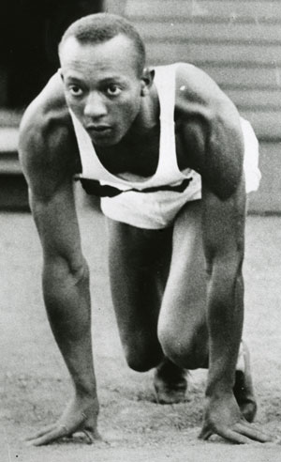

1. Why did people call Jesse a “floating wonder”?

O He was a good swimmer.

O He was a very fast runner.

O He had lucky legs.

1. Which of the following was NOT a job that Jesse had growing up?

O mowing lawns

O shining shoes

O delivering groceries

1. Why did Jesse have to meet Coach Riley in the mornings?

O The coach couldn’t stay after school to work with him.

O Jesse’s mom wouldn’t let him stay after school.

O Jesse worked in the afternoons.

1. Which word best describes Jesse Owens?

O hard-working

O angry

O lonely

How did Jesse feel about Coach Riley? Tell at least 3 details from the passage to support your answer.

__________________________________________________________________________________________________________________________________________________________________________________________________________________________________________________________________________________________________________________________________________________________________________________________________________________________________________________________________